**Name: Gaurang Vaghela**

**Rollno: TEAD-22561**

**DS (SL-III)**

**Practical 10**

**Code:**

**Download the Iris flower dataset or any other dataset into a DataFrame.(e.g.,**

**https://archive.ics.uci.edu/ml/datasets/Iris). Scan the dataset and give the inference as:**

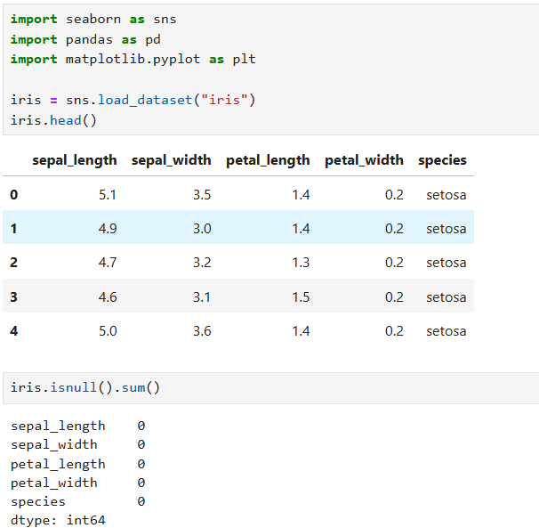

**1. List down the features and their types (e.g., numeric, nominal) available in the dataset.**

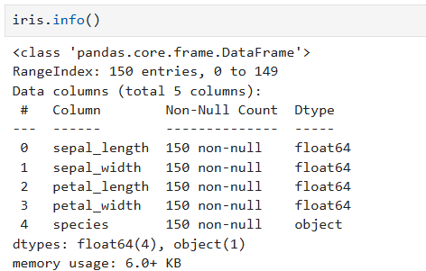

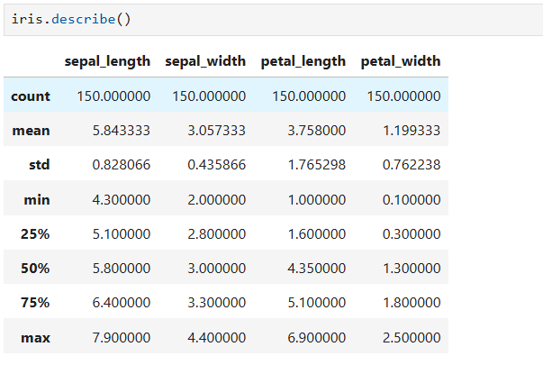

**2. Create a histogram for each feature in the dataset to illustrate the feature distributions.**

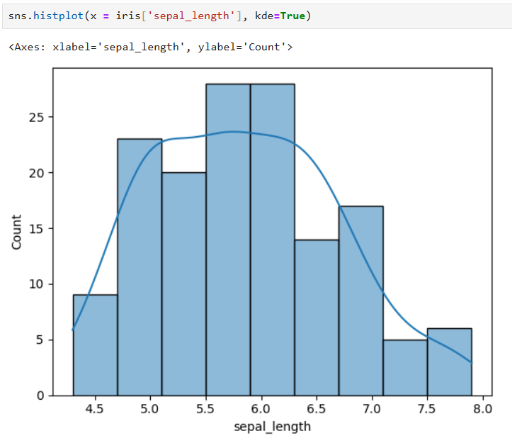

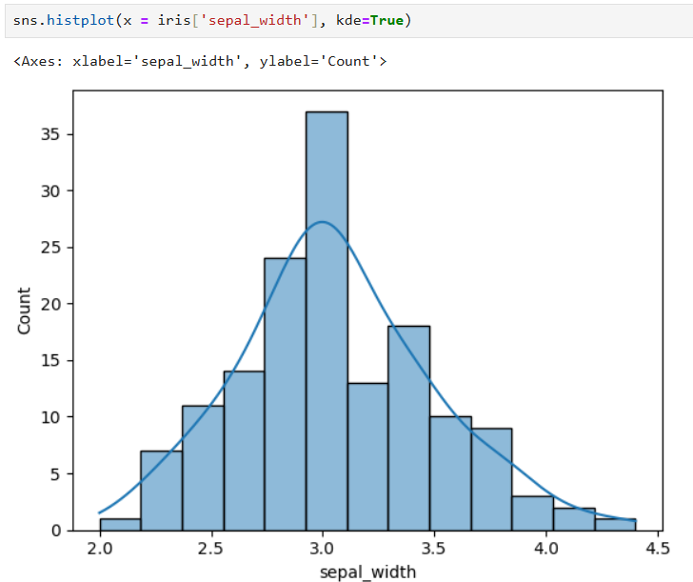

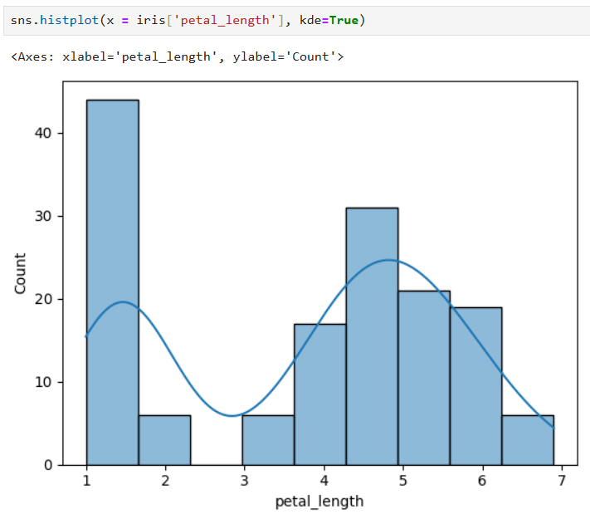

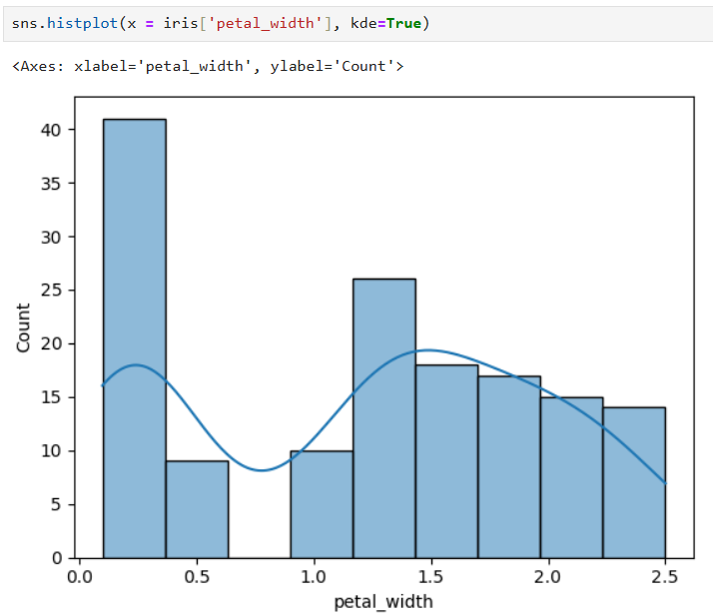

**3. Create a boxplot for each feature in the dataset.**

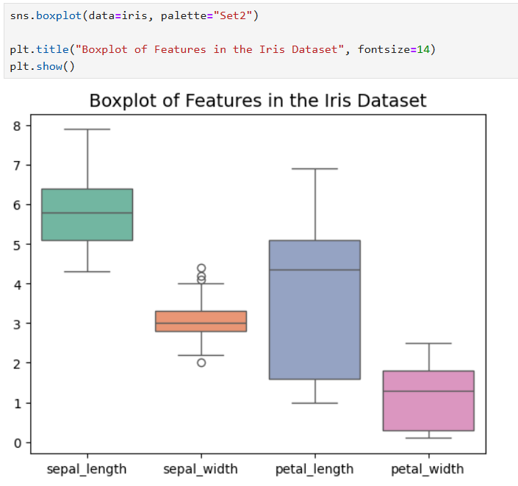

**4. Compare distributions and identify outliers.**

